**EXPERIMENT 5**

**DATE: 21/01/2020**

**PROJECT EFFORTSBASED ON RESOURCES**

* + - * Work Breakdown Structure
      * Risk analysis

|  |  |  |
| --- | --- | --- |
| **TASK** | **SUB TASK** | **WORK TO BE DONE** |
| 1. **ONLINE VOTING SYSTEM** | 1.1)Planning | Conceptual planning |
|  | 1.2)System analysis | Functional requirements  Technical requirements |
|  | 1.3)Design | Design review  Detailed project development |
|  | 1.4)Coding | Code Review  Finding errors |
|  | 1.5) Testing | Program Test  System test  Host test  Bug reporters |
|  | 1.6)Implementation | User documentation  System documentation |
|  | 1.7)Maintenance | Maintaining the system  Bug fixing  Review the system  Upgrade the system |
|  | **1.8)Final report documented** |  |

**WORK BREAK DOWN STRUCTURE**

A complex project is made manageable by first breaking it down into individual components in a hierarchical structure, known as the work breakdown structure, or WBS. Such a structure defines tasks that can be completed independently of other tasks, facilitating resource allocation, assignment of responsibilities, and measurement and control of the project

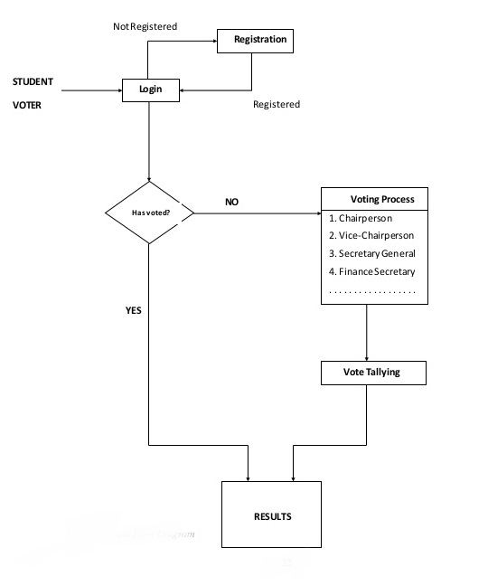

**RISK ANALYSIS**

A table provides a project manager with a simple technique for risk production. A risk table is sorted by probability and impact to rank risks. A project team begins by listing all risks in the 1st column of the table. This can accomplished with the help of the risk item checklist referenced. Each risk is categorized in the 2nd column. The probability of occurrence of each risk is entered in the next column of the table. Next, the impact of each risk is assessed. Each risk component is assessed using the characterization presented and an impact category is determine. The categories for each of the four risk components-performance, support, cost and schedule-are averaged to determine an overall impact value. Once the first four columns of the risk table have been completed, the table is sorted by probability and by impact. High-probability, high-impact, risk-impact risks percolate to the top of the table and low-probability risks drop to the bottom

|  |  |  |  |  |
| --- | --- | --- | --- | --- |
| **Risk** | **Category** | **Probability** | **Impact** | **RMMM** |
| Hacker attack | TE | 30% | 1 | Appoint experts team to overcome the situation. |
| Environmental factors | BU | 30% | 2 | Replication to different data centers |
| Delivery deadline will be tightened | BU | 50% | 2 | Increase the amount of resources available. |
| Staff inexperienced | ST | 30% | 2 | Meet with experienced developer and experts of projects. |
| Size estimates may be significantly low | PS | 60% | 2 | Check the modules and revise the algorithm |
| Staff turnover will be high | ST | 60% | 2 | Meet with current staff to determine causes for turnover. Assign the backup staff member for every critical technologist. |
| Less reuse than planned | PS | 70% | 2 | Revise the components than to be used |
| Performance | TE | 20% | 2 | Revise the components than to be used |
| Unavailability of team members | BU | 20% | 3 | Ensure that there is always an emergency person who can always take over the task assign is not available |
| Unavailability of team members | BU | 30% | 3 | Set dates for reviews for each documentation |

|  |  |  |  |
| --- | --- | --- | --- |
| **Presentation (4)** | **Documentation (3)** | **Explanation (3)** | **Total (10)** |
|  |  |  |  |